SET 8 – Employee Performance Analysis Dataset
Employee ID | Department | Years of Service | Performance Score
1 | Sales | 5 | 85
2 | HR | 3 | 92
3 | Marketing | 7 | 78

Q1. Line Chart – Performance Trend
Aim:
To visualize employee performance scores according to years of service.
R Code:
employee_data <- data.frame(
Employee_ID = c(1, 2, 3),
Department = c("Sales", "HR", "Marketing"),
Years_of_Service = c(5, 3, 7),
Performance_Score = c(85, 92, 78)
)

employee_data <- employee_data[order(employee_data$Years_of_Service), ]

plot(employee_data$Years_of_Service,
employee_data$Performance_Score,
type = "o",
main = "Employee Performance Trend",
xlab = "Years of Service",
ylab = "Performance Score")
Observation:
The highest performance score is 92 for the HR employee with 3 years of service. The lowest score is 78 for the Marketing employee with 7 years of service.
Output:
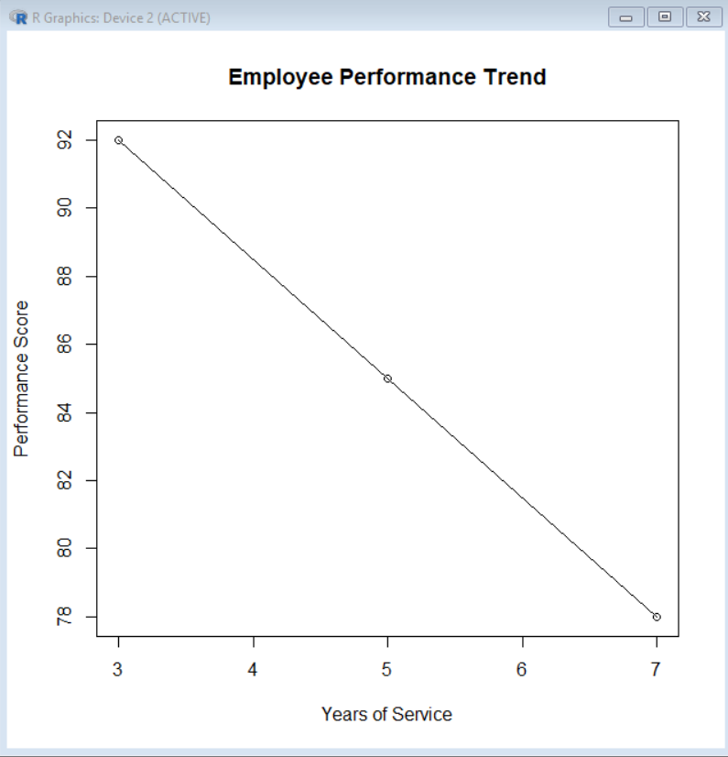

Q2. Bar Chart – Employees by Department
Aim:
To show the distribution of employees across departments.
R Code:
dept_count <- table(employee_data$Department)

barplot(dept_count,
main = "Employees by Department",
xlab = "Department",
ylab = "Number of Employees",
col = "lightgreen")
Observation:
Each department has one employee.
Output:
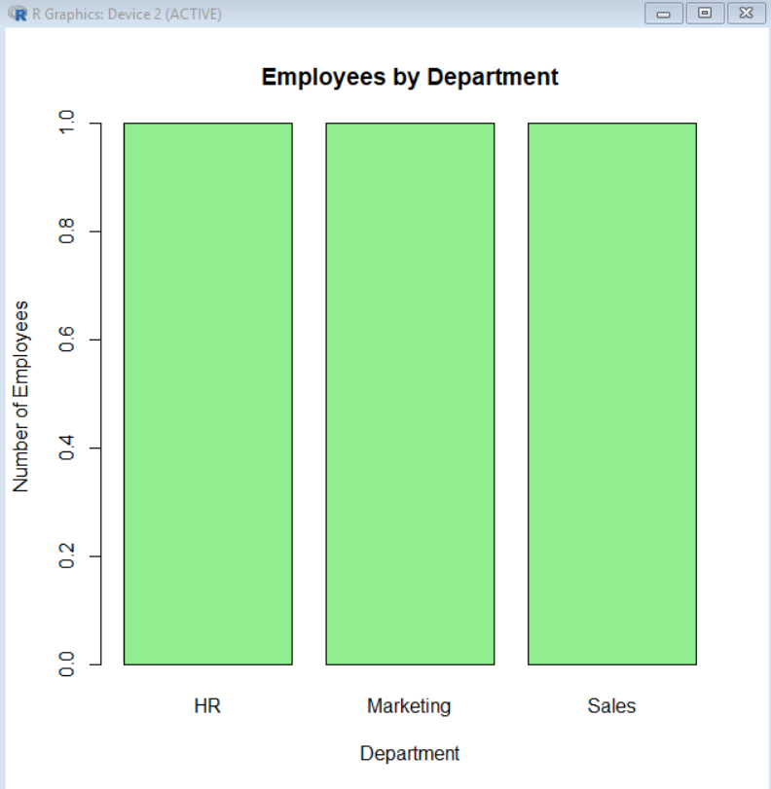

Q3. Employee Performance Table
Aim:
To display the performance information of each employee.
R Code:
print(employee_data)
Table:
Employee ID | Department | Years of Service | Performance Score
1 | Sales | 5 | 85
2 | HR | 3 | 92
3 | Marketing | 7 | 78
Table Elements:
- Employee ID – identifies employee
- Department – employee's department
- Years of Service – experience in the organization
- Performance Score – employee performance rating
Output:
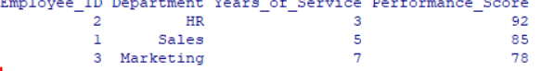

Q4. Tableau Dashboard
Dashboard Components:
- Employee Performance Line Chart
- Department Bar Chart
- Employee Performance Table
Procedure:
- Import the employee dataset into Tableau.
- Create a line chart using Years of Service and Performance Score.
- Create a bar chart using Department and Employee ID.
- Create a table using all employee fields.
- Create a new dashboard.
- Drag the three sheets onto the dashboard.
- Add filters for Department or Years of Service.
- Arrange the sheets neatly.
Result:
An interactive Tableau dashboard is created for exploring employee performance and departmental information.

